APRIL 2022
Sunday | Monday | Tuesday | Wednesday | Thursday | Friday | Saturday
27 | 28 | 29 | 30 | 31 | 1 | 2
3 | 4 | 5 | 6 | 7 | 8 | 9
10 | 11 | 12 | 13 | 14 | 15 | 16
RAM NAVAMI |  |  |  | AMBEDKER JAYANTI | GOOD FRIDAY
17 | 18  SCHOOL RE-OPENS FOR NEW SESSION | 19 | 20 | 21 | 22 | 23
24 | 25 | 26  CBSE Board Exam | 27 | 28 | 29 | 30
 |  |  | CBSE Board Exam | CBSE Board Exam
1 | 2 | 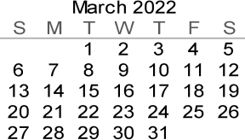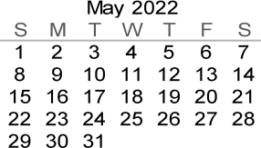 |  |  | FOR IX-XII AS PER CBSE INSTRUCTION

MAY 2022
 | Sunday | Monday |  | Tuesday |  | Wednesday | Thursday | Friday | Saturday
1 |  | 2 |  | 3 |  | 4  Link State Dadra Nagar Haveli Act | 5 | 6 | 7
 |  | CBSE Board Exam |  | ID-Ul-FITR |  |  | CBSE Board Exam | CBSE Board Exam | CBSE Board Exam
8 |  | 9 |  | 10 |  | 11 | 12 | 13 | 14
 |  | Painting Competition |  | CBSE Board Exam |  | Fabric & Pot Painting competition | CBSE Board Exam | CBSE Board Exam | CBSE Board Exam
15 |  | 16 |  | 17 |  | 18 | 19 | 20  CBSE Board Exam | 21
 |  | BUDH PURNIMA |  | CBSE Board Exam |  | CBSE Board Exam
22 |  | 23  CBSE Board Exam |  | 24 |  | 25 | 26 | 27 | 28
 |  |  |  | CBSE Board Exam |  |  |  |  | CBSE Board Exam
29 |  | 30  CBSE Board Exam |  | 31 |  | 1 | 2 | 3 | 4
 |  |  |  |  |  | SUMMER BREAK (23.05.2022-30.06.2022)
5 |  | 6 |  | 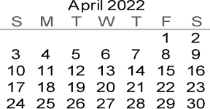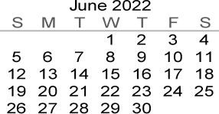

JUNE 2022
Sunday | Monday | Tuesday | Wednesday | Thursday | Friday | Saturday
29 | 30 | 31 | 1 | 2 | 3 | 4
 |  |  |  | CBSE Board Exam
5 | 6  CBSE Board Exam | 7  CBSE Board Exam | 8 | 9 | 10 | 11
12 | 13  CBSE Board Exam | 14  CBSE Board Exam | 15  CBSE Board Exam | 16 | 17 | 18
19 | 20 | 21 | 22 | 23 | 24 | 25
26 | 27 | 28 | 29 | 30
3 | 4 | 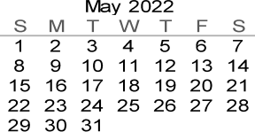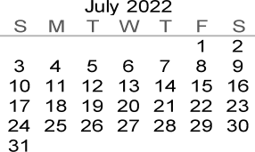

JULY 2022
Sunday | Monday | Tuesday | Wednesday | Thursday | Friday | Saturday
 |  |  |  |  | 1  SCHOOL REOPENS AFTER SUMMER BREAK | 2
3 | 4  Fa1  Pt 1 | 5  Fa1  Pt 1 | 6  Fa1  Pt 1 | 7  Fa1  Pt 1 | 8  Fa1  Pt 1 | 9
10 | 11  Fa1  Pt 1 | 12 | 13 | 14 | 15 | 16
ID-ul-ADHA |  |  |  | FIRE DRILL
17 | 18 | 19 | 20 | 21 | 22 | 23  PTM regarding  Har Ghar Tiranga Program
 |  |  | School Assembly  Har Ghar Tiranga | Declamation Contest | Essay Writing Competition
24 | 25  Awareness  Ralley on Har Ghar Tiranga Program | 26  Poem recitation | 27  Story Telling on Famous National Leaders | 28  Nukkar Play Skit | 29  Collage Making | 30  Poster Making
31 |  | 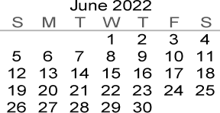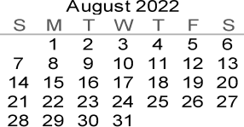

 |  |  |  | AUGUST 2022
 | Sunday | Monday |  | Tuesday |  | Wednesday | Thursday |  |  | Friday | Saturday
31 |  | 1  Song Competition |  | 2  Youth Parliament in School |  | 3  Slogan Writing | 4  Prabhat Pheri By NCC & NSS Students |  | 5  Tree Plantation & Yoga |  | 6  Rangoli Competition
7 |  | 8 |  | 9 |  | 10 | 11 |  | 12 |  | 13
 |  | Face &  Hand Painting  Competition |  | Muharram |  | Special school assembly on Har Ghar Tiranga & Quiz | RAKSHA BANDHAN |  | Exhibition by the students
14 |  | 15 |  | 16 |  | 17 | 18 |  | 19 |  | 20
 |  | INDEPENDENCE DAY |  |  |  |  |  |  | JANAMASHTMI
21 |  | 22 |  | 23 |  | 24 | 25 |  | 26 |  | 27
 |  | Activity related to link state with Dadra Nagar Haveli |  |  |  | Quiz on link state with Dadra Nagar Haveli
28 |  | 29 |  | 30 |  | 31
4 |  | 5 |  | 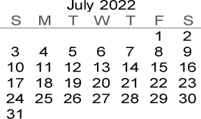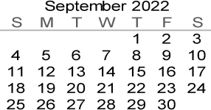

SEPTEMBER 2022
 | Sunday | Monday |  | Tuesday | Wednesday | Thursday | Friday | Saturday
 |  |  |  |  |  | 1  Poshan Pledge | 2  Poshan awareness Ralley | 3  Door to Door  Awareness regarding Pashan Mah
4 |  | 5 |  | 6 7  Door to Door Survey & interaction of volunteers on nutrition |  | 8  Poster making on Poshan Mah | 9 | 10
 |  | TEACHERS' DAY
 |  |  |  |  |  |  | Poster on Water Management
11 |  | 12 |  | 13  Promote learning about nutrition through games | 14 | 15  Essay/Poster competition on Poshan Mah | 16 | 17  Awareness drive for parents on nutritious diet
 |  | Khelo aur Padho toys |  |  |  |  | Activity on Balanced Diet
18 |  | 19 |  | 20 | 21 | 22 | 23 | 24  Awareness about Girls Health
 |  | Yoga Asanas |  | Interaction on Health | Yoga Camp | Organise Health Club | Term 1 Examination  (VI to XII)
25 |  | 26 |  | 27 | 28 | 29  Term 1 Examination  (VI to XII) | 30  Term 1 Examination  (VI to XII) | 1
 |  | Term 1 Examination  (VI to XII) |  | Term 1 Examination  (VI to XII) | Term 1 Examination  (VI to XII)
2 |  | 3 |  | 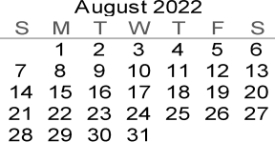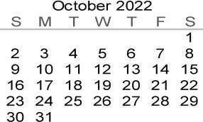 |  |  | IX-XI SUBJECT TO CBSE INSTRUCTIONS
*SUBJECT TO CHANGE

